接線圖:

HC05

RXD->PD8

TXD->PB11

VCC50->5V

VCC33->3V

GND->GND

LCD16x2

SCL->PA8

SDA->PC9

VCC->5V

GND->GND

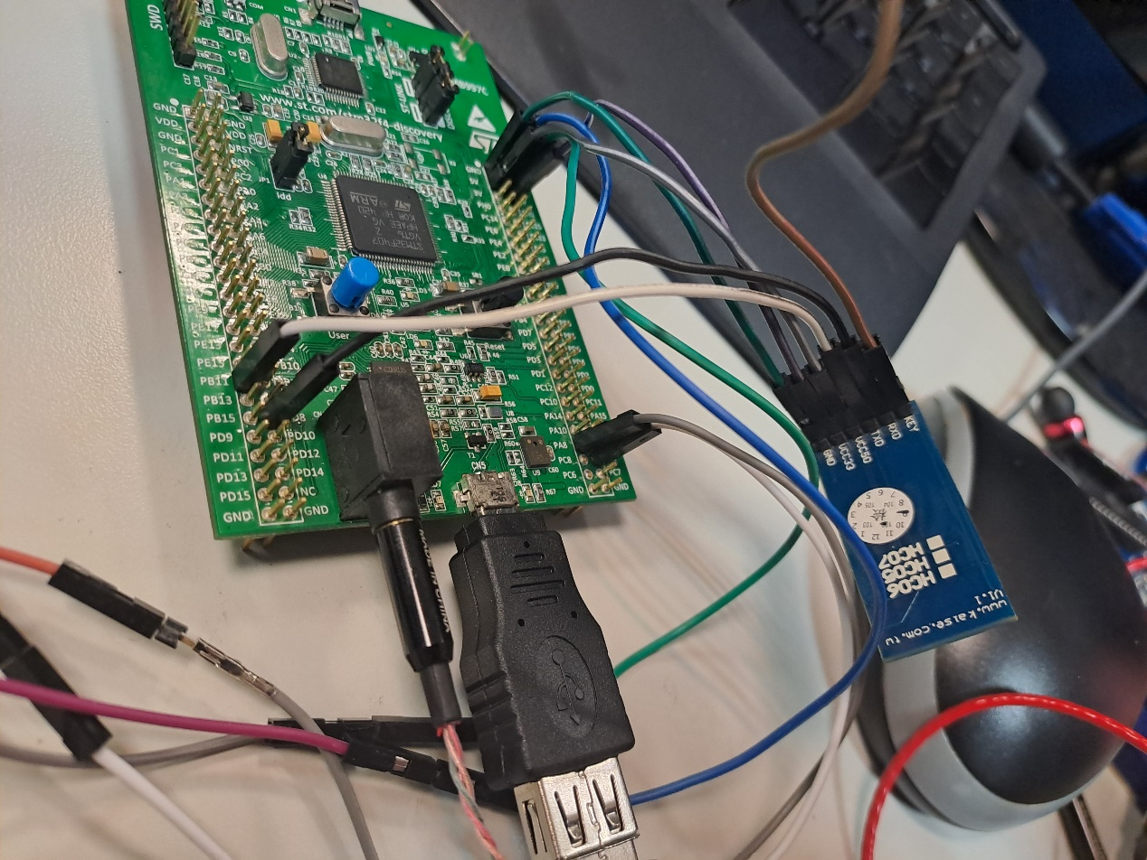

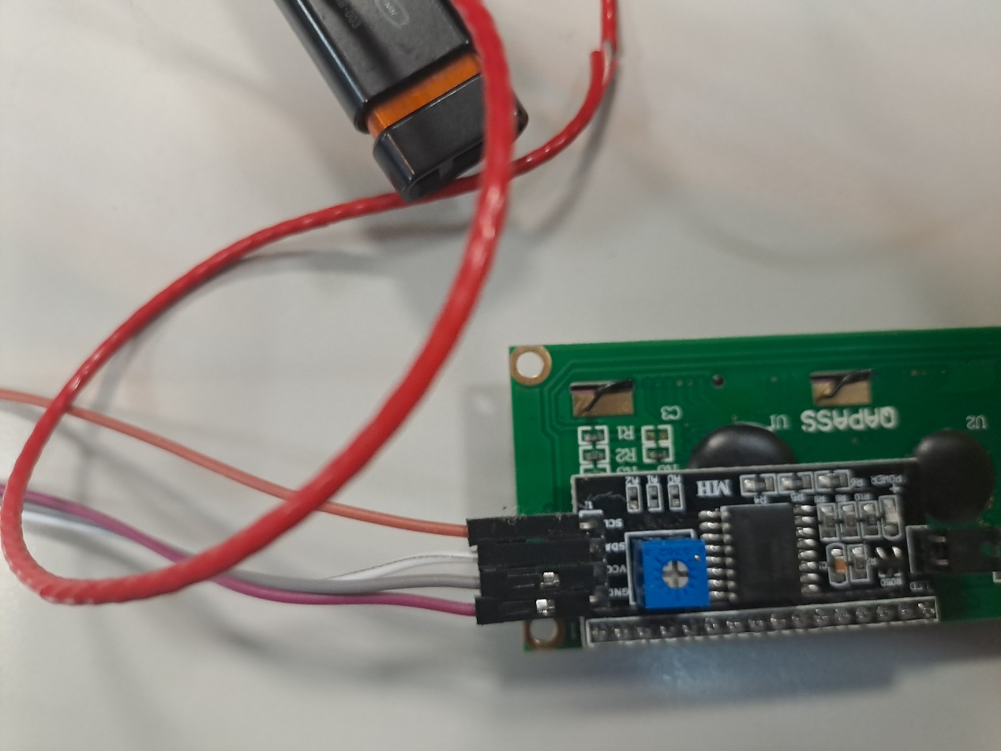

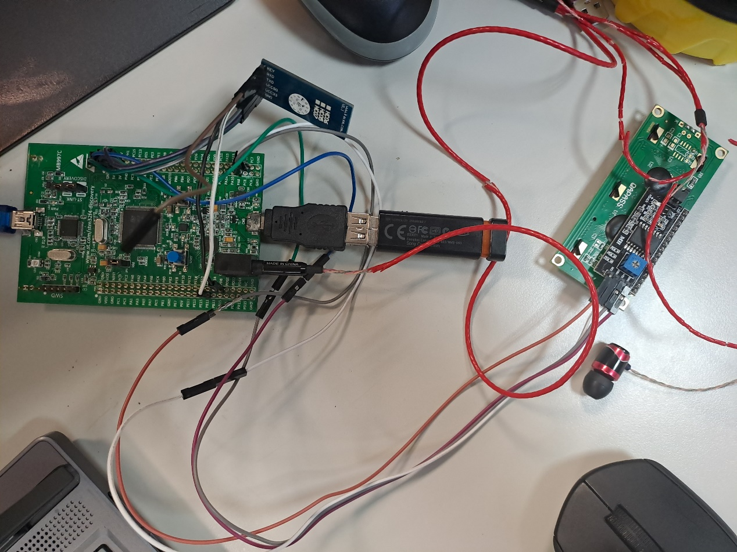

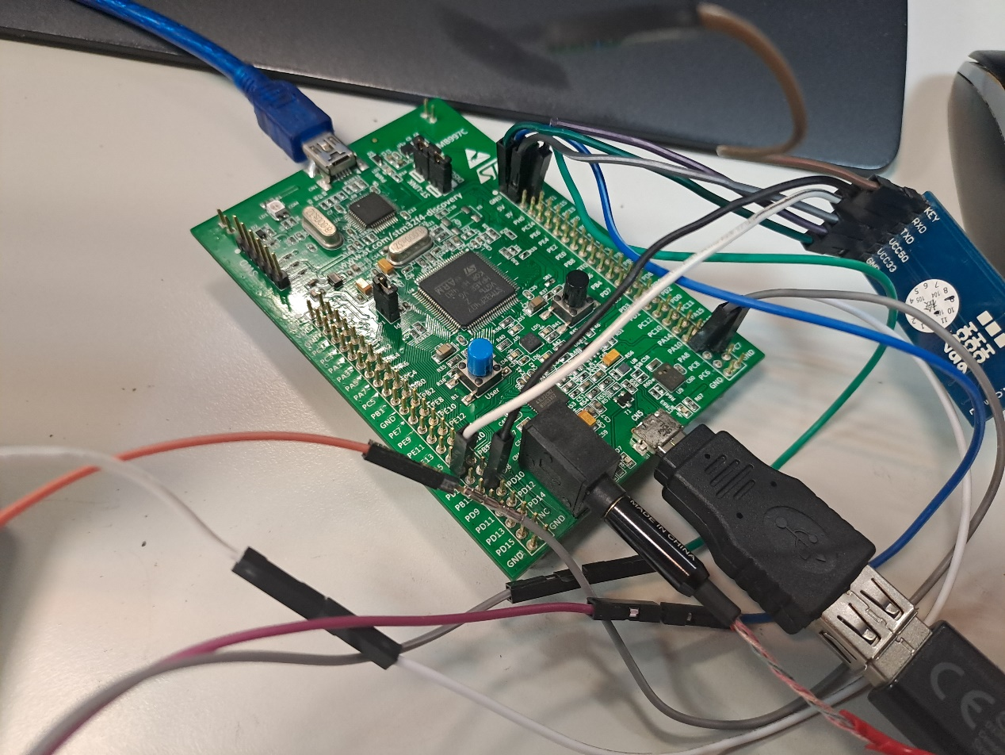

DEMO

S1. Not connect with USB, notice Orange_LCD:

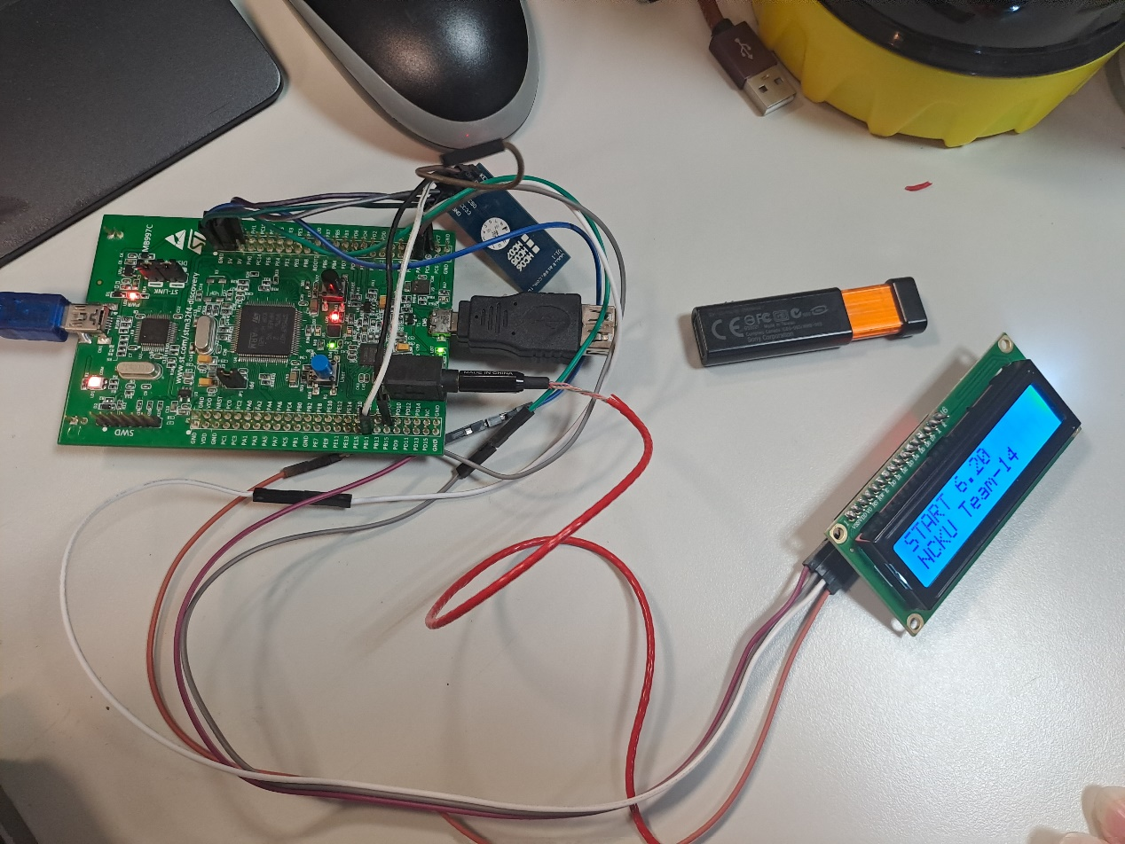

S2. Connect with USB, notice Orange_LCD:

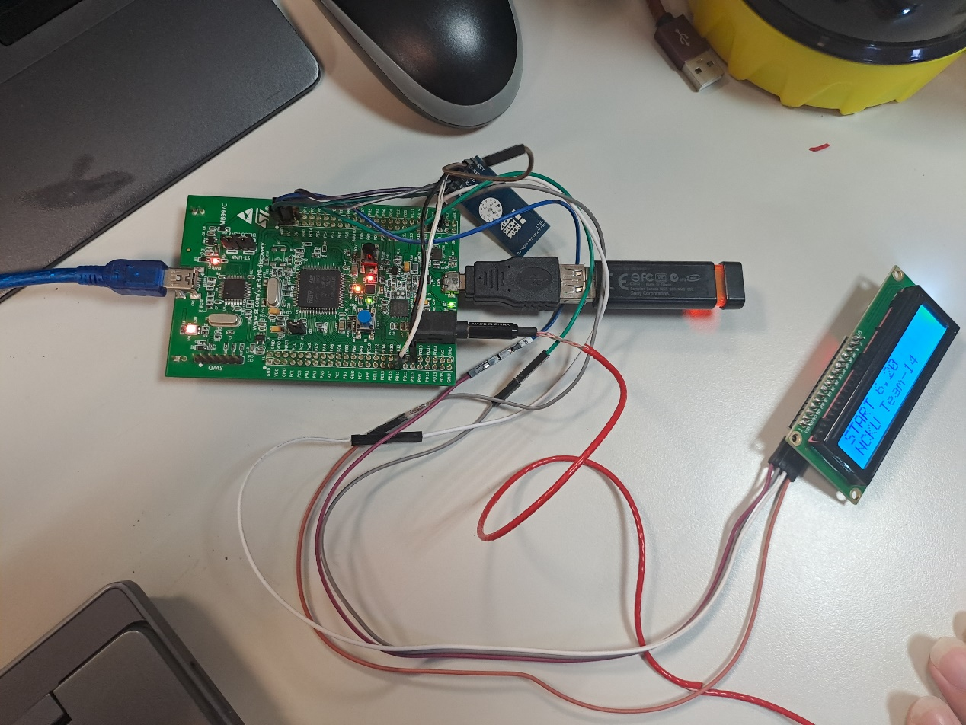

S3. Push Blue_button to next song:

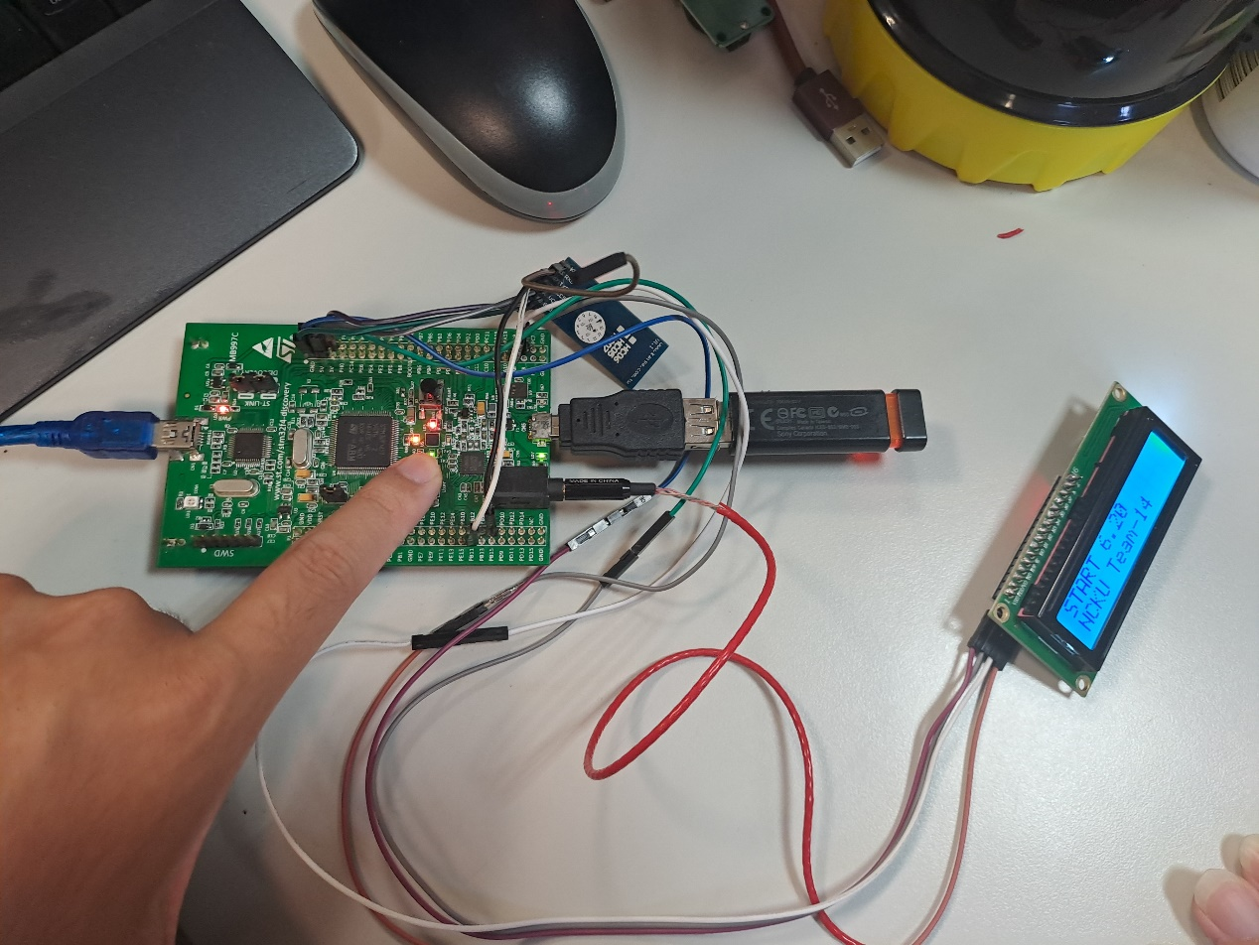

S4. Download Bluetooth app on your smartphone:

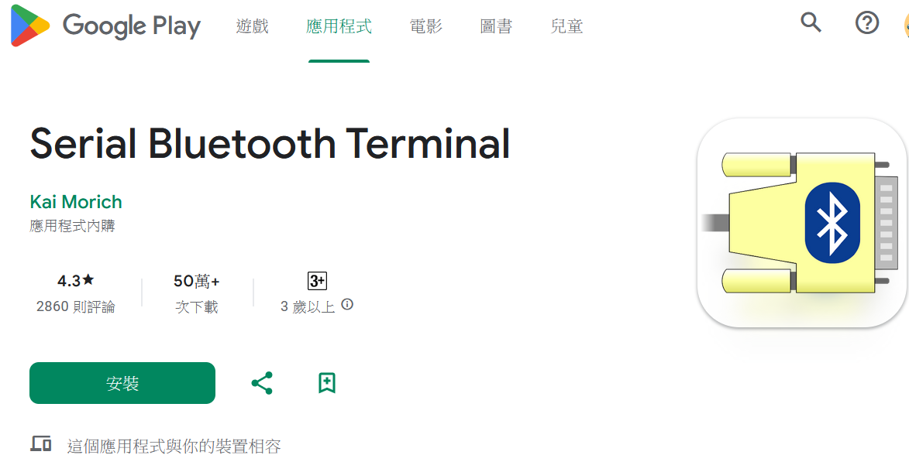

S5. Set app:

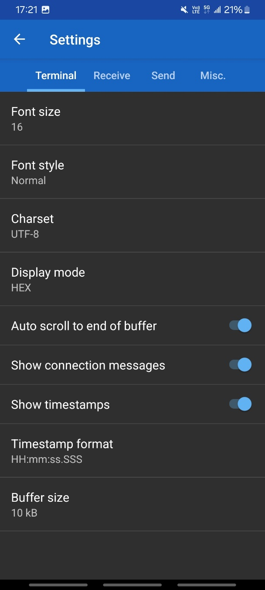 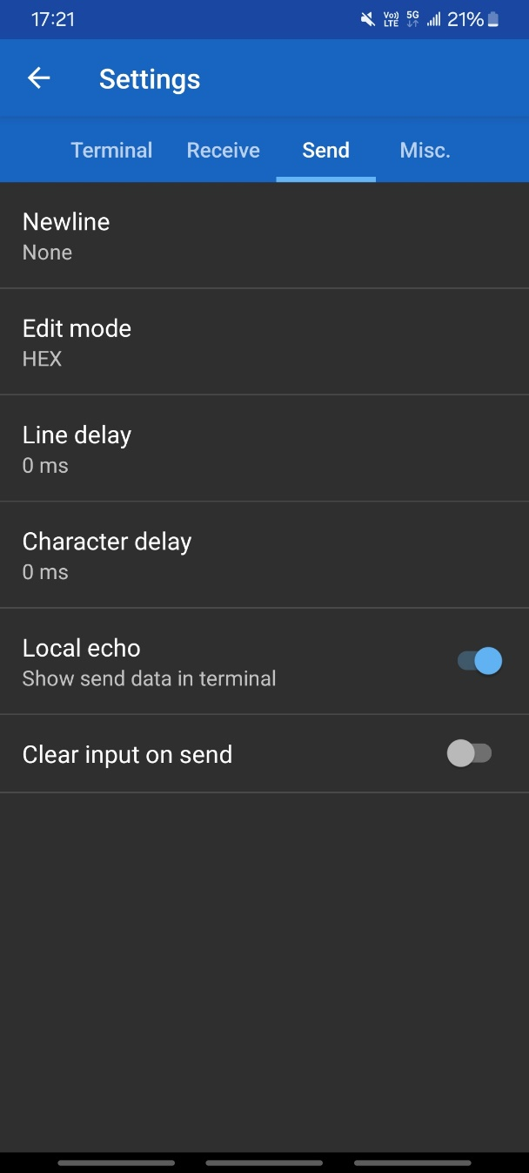

S6. Connect HC05 (default secret number: 000 or 1234, my device is 1234):

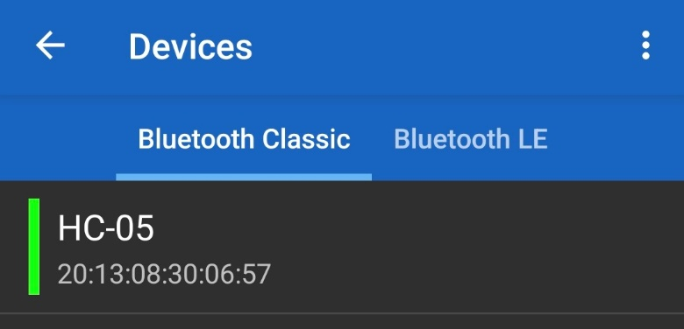

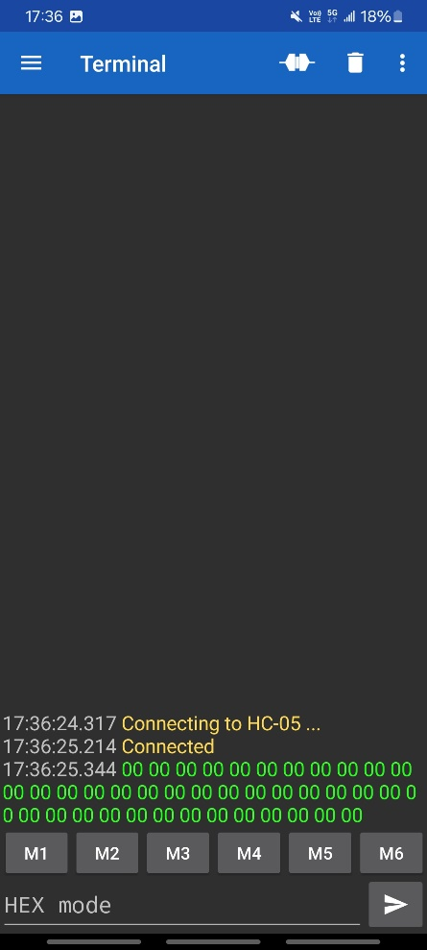

S7. Send command (AA->HC05 require, 04->command length, 00->next song, 00->for encryption {ex: sum}):

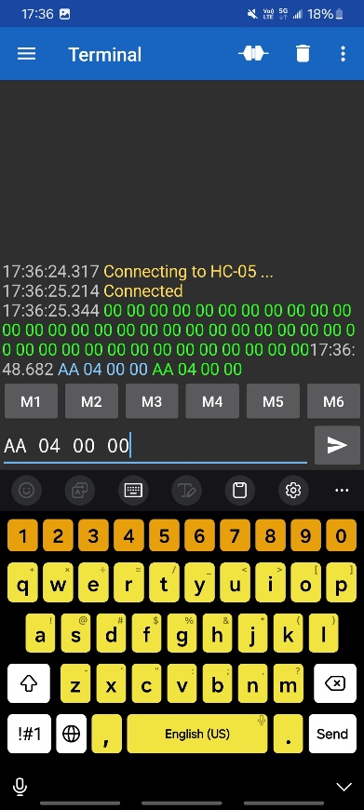

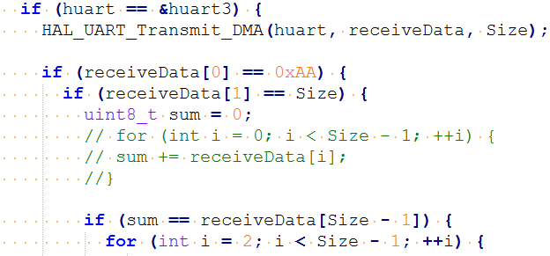

S8. Send command (01->previous song):

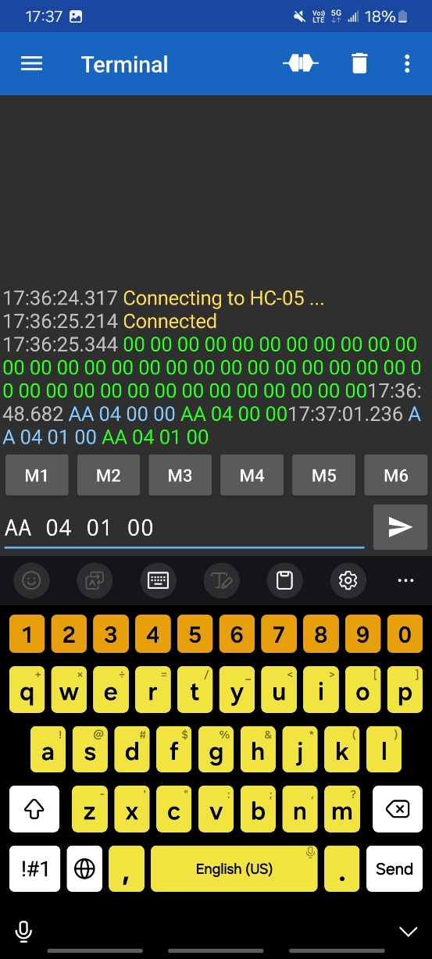

S9. Send command (02->volumn up):

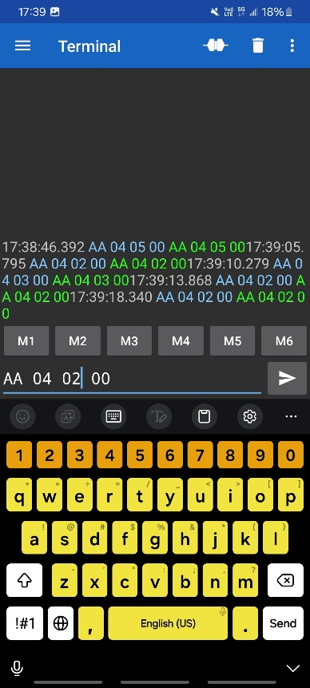

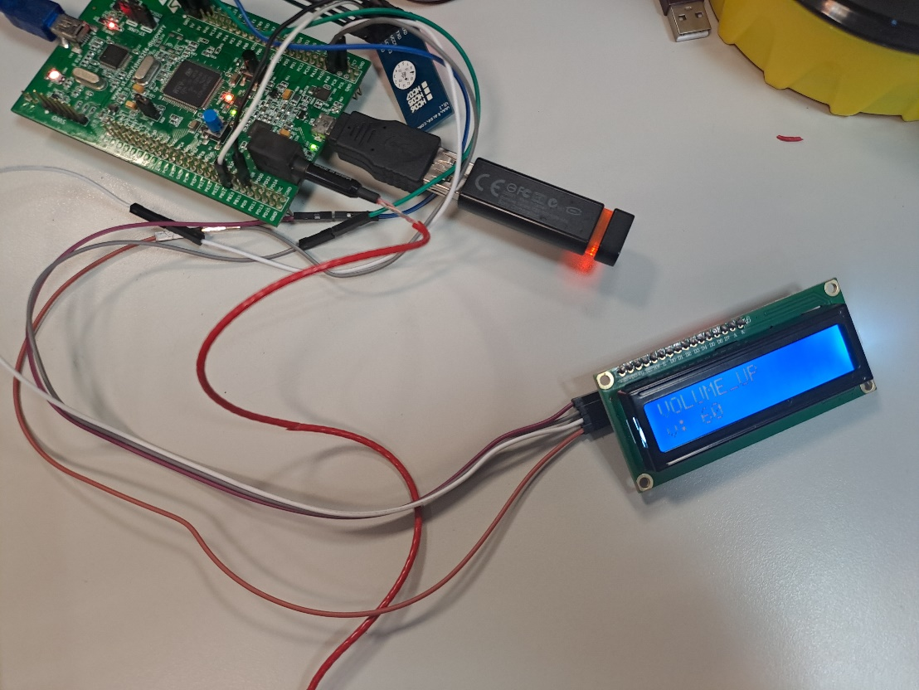

S10. Send command (03->volumn down):

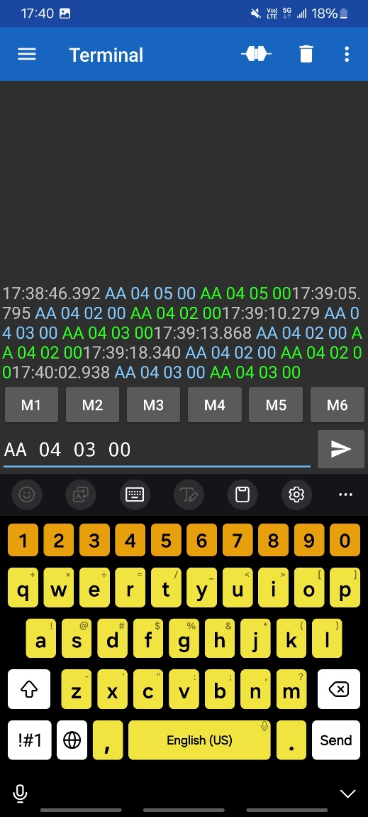

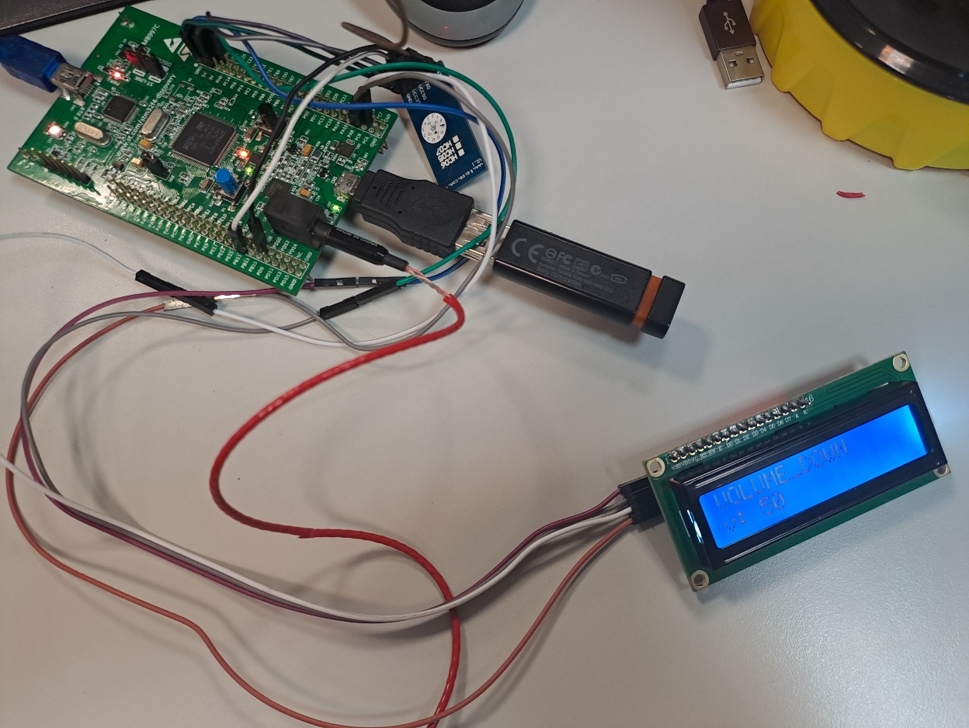

S11. Send command (04->pause):

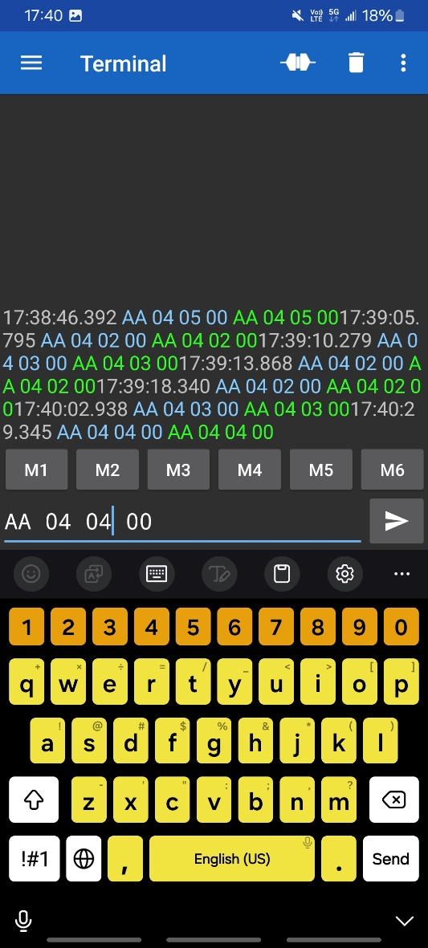

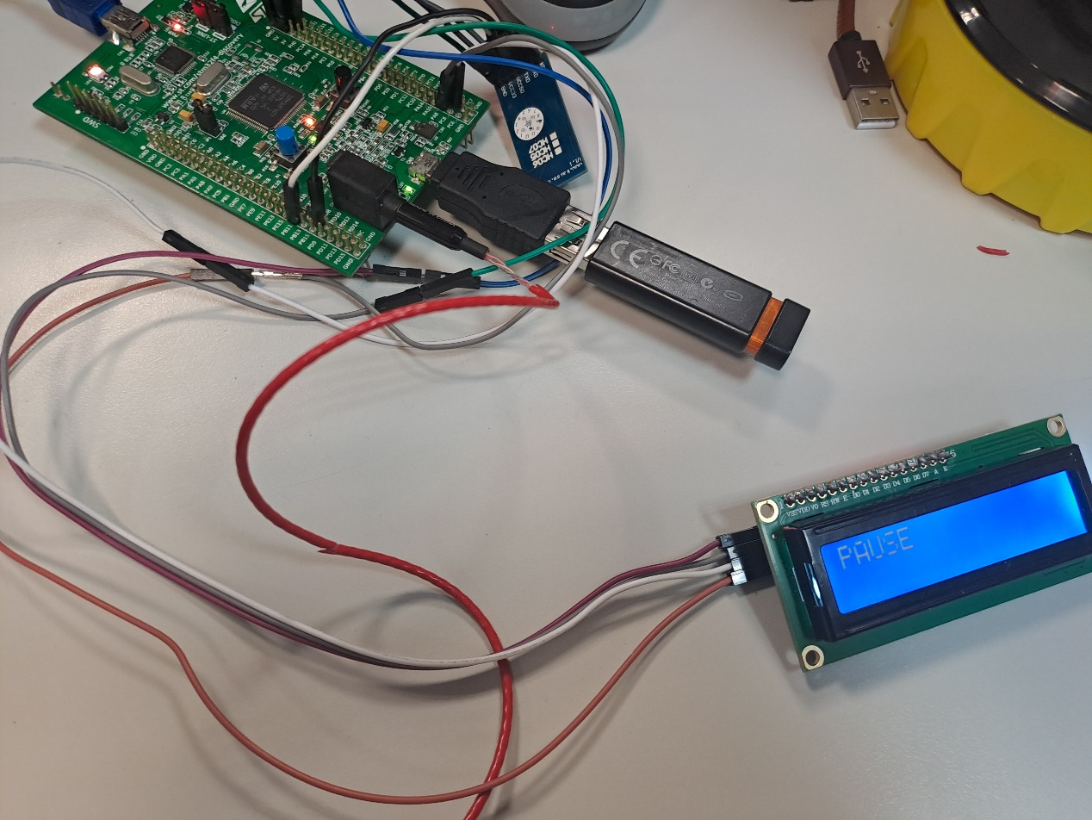

S12. Send command (05->resume):

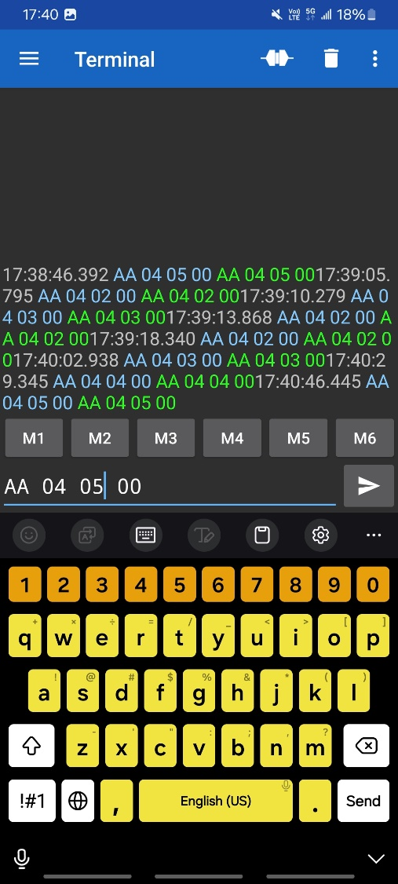

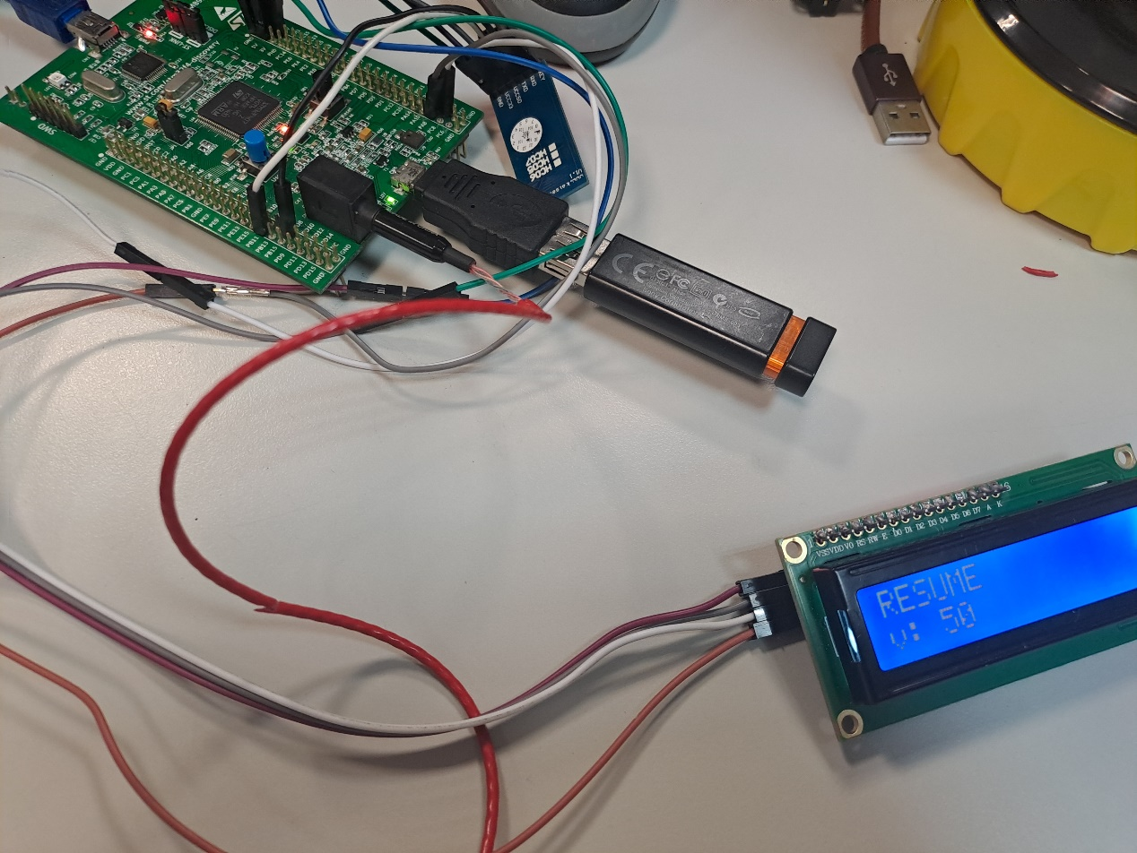

S13. Send command (error detect 0A is wrong):

